

**MIEIC – December 2017**

**Software Development in Practice**

**ESOF**

**Class 1 - Group F**

**Diogo Peixoto Pereira – up201504326**

**Maria Eduarda Santos Cunha – up201506524**

**Pedro Miguel Ferraz Nogueira da Silva – up201505460**

Index

1. Open Source Project 3

1.1. Why did we choose this Project? 3

1.2. How alive is this project? 3

1.3. How important is it? 3

1.4. What is it good for? 3

1.5. What are the technologies involved? 3

2. Issues 4

2.1. Issue #39549 4

2.2. Issue #39606 5

# Open Source Project

## Why did we choose this Project?

Visual Studio Code was launched on the 29th of April, in 2015 and was developed by Microsoft.

One of the reasons for the class to choose this project is because it was "alive" enough for us to get some feedback from the developers.

Also, it had a tremendous amount of issues to be fixed. That means that there are a lot of options for all groups to choose an issue and fix it.

## How alive is this project?

Visual Studio Code has almost daily updates and the community seems to be very active.

Since its creation it’s been famously growing in the developing community.

There are currently around 4000 open issues, nearly 5000 contributors and over 27000 commits.

## How important is it?

Visual Studio is becoming more and more used and loved among programmers because it has a lot of important and useful tools such as Git, IntelliSense, auto-completion and many more that help the life of many programmers.

## What is it good for?

Editing, building and debugging with ease.

It is able to incorporate different languages in the same code editor, with multiple extensions.

IntelliSense TM Technology allows for easier coding and auto-completion.

## What are the technologies involved?

Visual Studio Code is developed using TypeScript as the programming language. It also uses a well-known library called Electron which allows the creation of a desktop application using web based programming languages such as JavaScript, HTML and CSS for all platforms (Windows, Linux and MacOS).

# Issues

## Issue #39549

**Issue:**

<https://github.com/Microsoft/vscode/issues/39549>

**Description:**

Fig 1: Issue #39549 description by the issue’s submitter

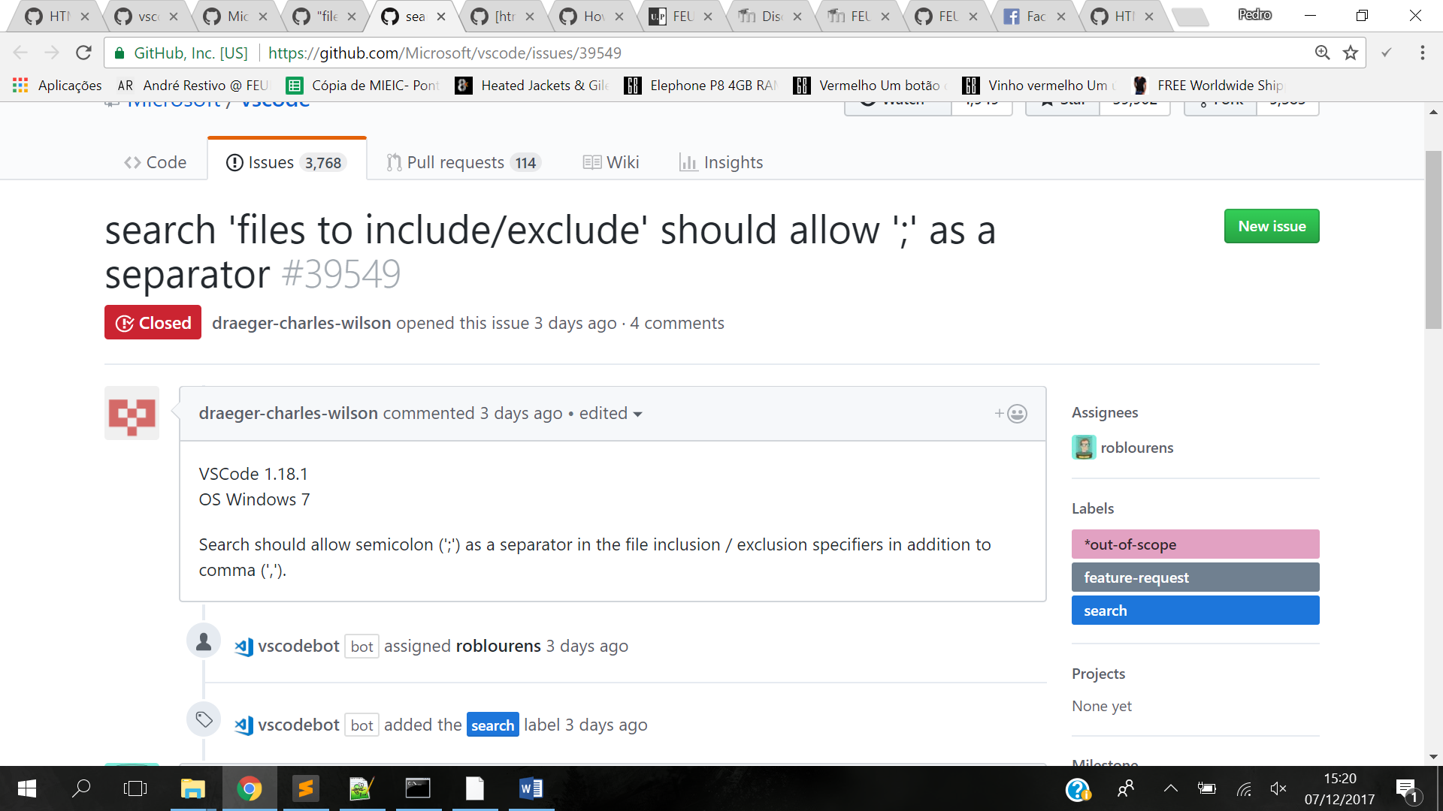When searching for the files to include/exclude, they were separated by a comma, but should be separated by a ‘;’ instead, like what happens in Visual Studio.



As <*User> <searching for something in files to include/not in files to exclude>,* I want <*to separate the different files with ‘;’ >* because <*the separator in proper VisualStudio is a semicolon>*.

**Requirements:**

In terms of user stories, we can explain our requirements in this way:

Before we solve the issue, VScode would act like this:

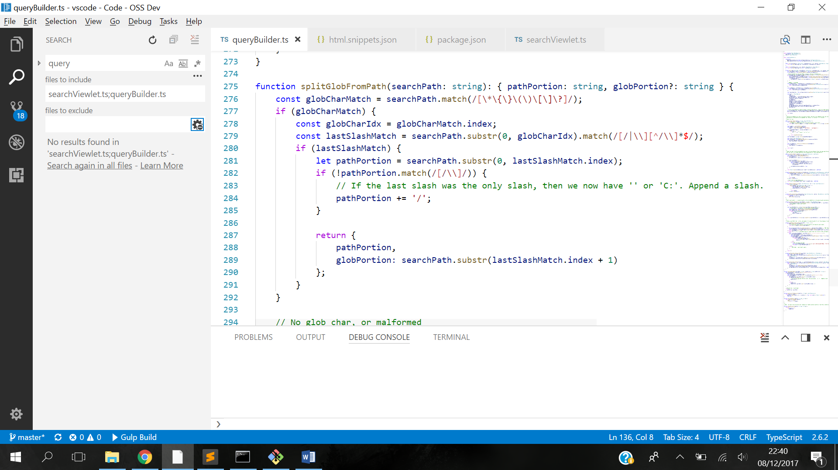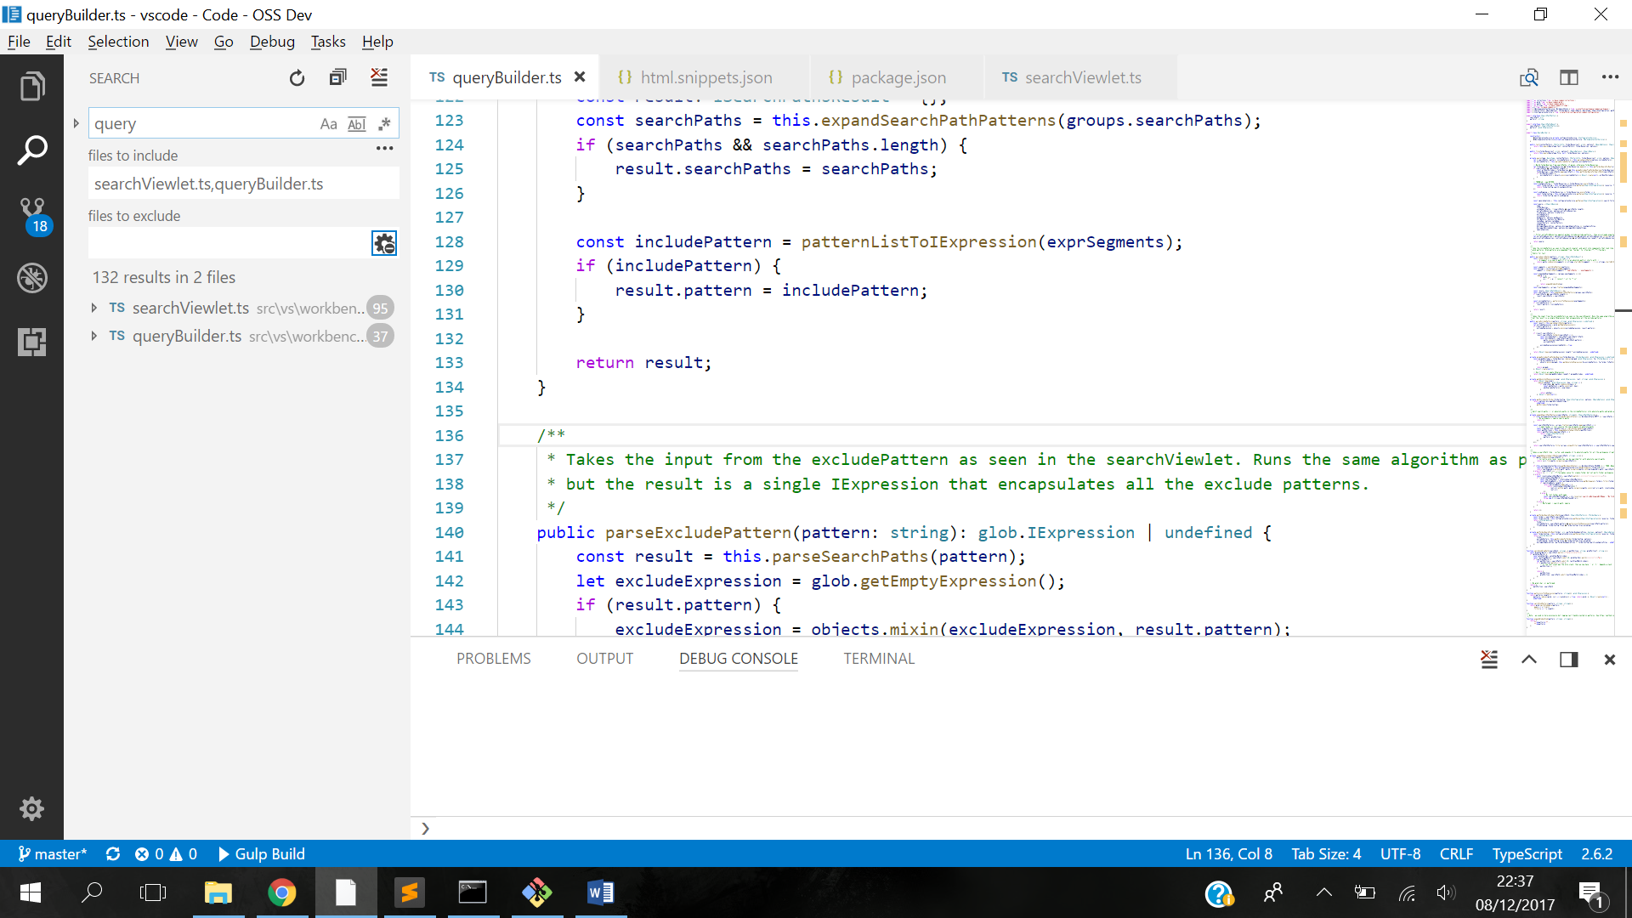

Fig 3: Using ‘;’ as separator, VScode could not distinguish different files.

Fig 2: Separator of different files to include was comma.

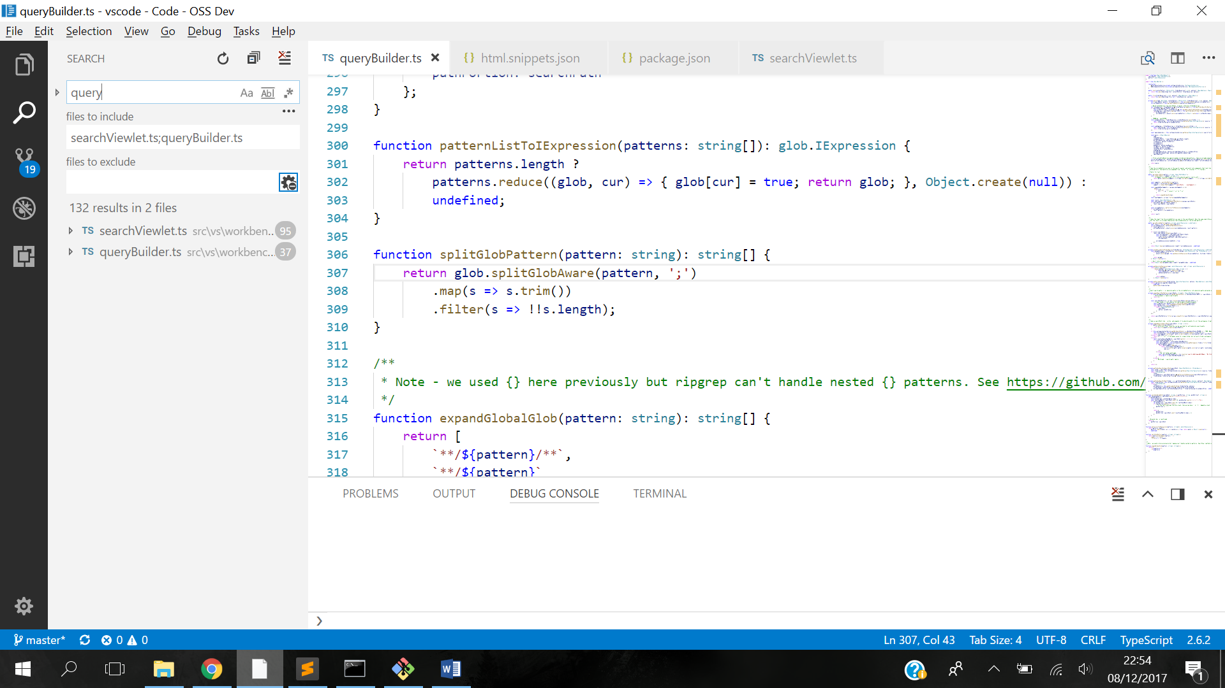What was intended was that VScode act like this:

Fig 4: Using ‘;’ as separator, like in Visual Studio.

**Source code files:**

In order to solve the issue, we made a change in the function splitGlobPattern(pattern: string), which can be found in the line 306, in the file [vscode/src/vs/workbench/parts/search/common/queryBuilder.ts](https://github.com/Microsoft/vscode/blob/daf63a3ad169cd8161ddbadf3fe3f2a414f93800/src/vs/workbench/parts/search/common/queryBuilder.ts#L306).

**Design of the fix:**

With this simple UML, we are trying to show the sequence of function calls that allowed us to plan and find the correct place to solve the issue:

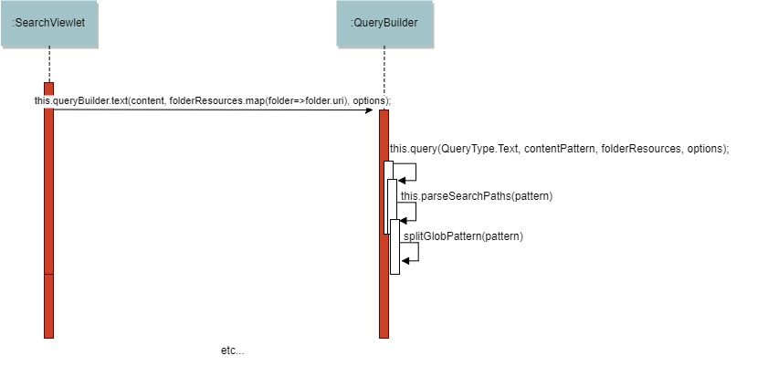

And it was in this function that we changed the ‘,’ separator to ‘;’

**Fix** **source** **code:**

src/vs/workbench/parts/search/common/queryBuilder.ts | 2 +-

1 file changed, 1 insertion(+), 1 deletion(-)

diff --git a/src/vs/workbench/parts/search/common/queryBuilder.ts b/src/vs/workbench/parts/search/common/queryBuilder.ts

index 5c8e0d65015..5c0cabdd0aa 100644

--- a/src/vs/workbench/parts/search/common/queryBuilder.ts

+++ b/src/vs/workbench/parts/search/common/queryBuilder.ts

@@ -304,7 +304,7 @@ function patternListToIExpression(patterns: string[]): glob.IExpression {

}

function splitGlobPattern(pattern: string): string[] {

- return glob.splitGlobAware(pattern, ',')

+ return glob.splitGlobAware(pattern, ';')

.map(s => s.trim())

.filter(s => !!s.length);

}

**Submit the Fix:**

The way it was supposed to submit fixes in our project is by doing a pull request, that can be found here:

<https://github.com/Microsoft/vscode/pull/39821>

## Issue #39606

**Issue:**

<https://github.com/Microsoft/vscode/issues/39606>

**Description:**

Allow for Html code completion for scripts.

In this case, this user wanted to type some parts of script/Html relatable code and have VScode automatically suggest the completion of it.

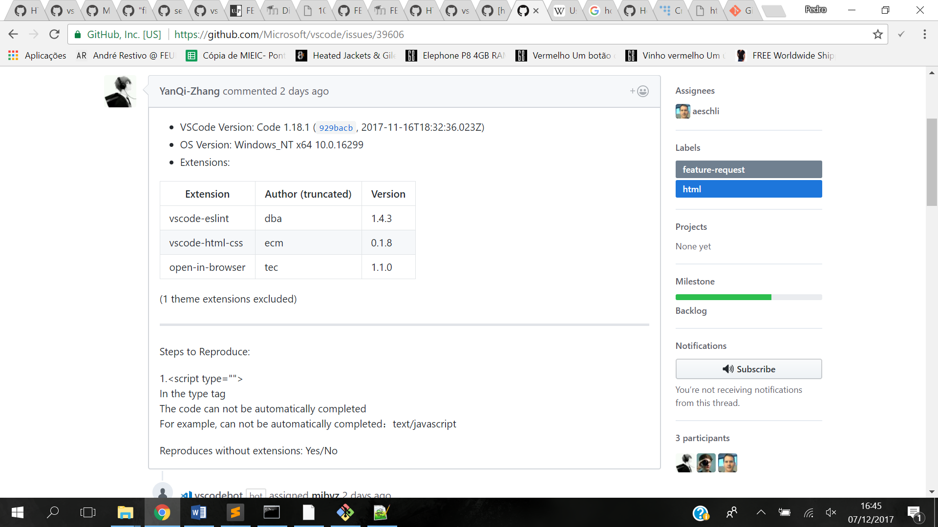

Fig 5: Issue #39606 description by the issue’s submitter



As a *<User>,* I want *<html code to have automatically completed>.*

**Requirements:**

In terms of user stories, we can explain our requirements in this way:

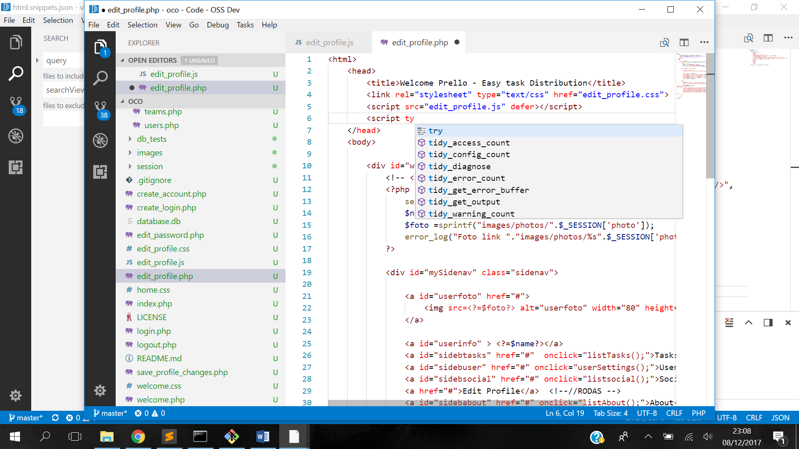Before the issue was solved, VScode would act like this:

Fig 6: Different code typing that show there is not a suggestion to automatically complete this html relatable code

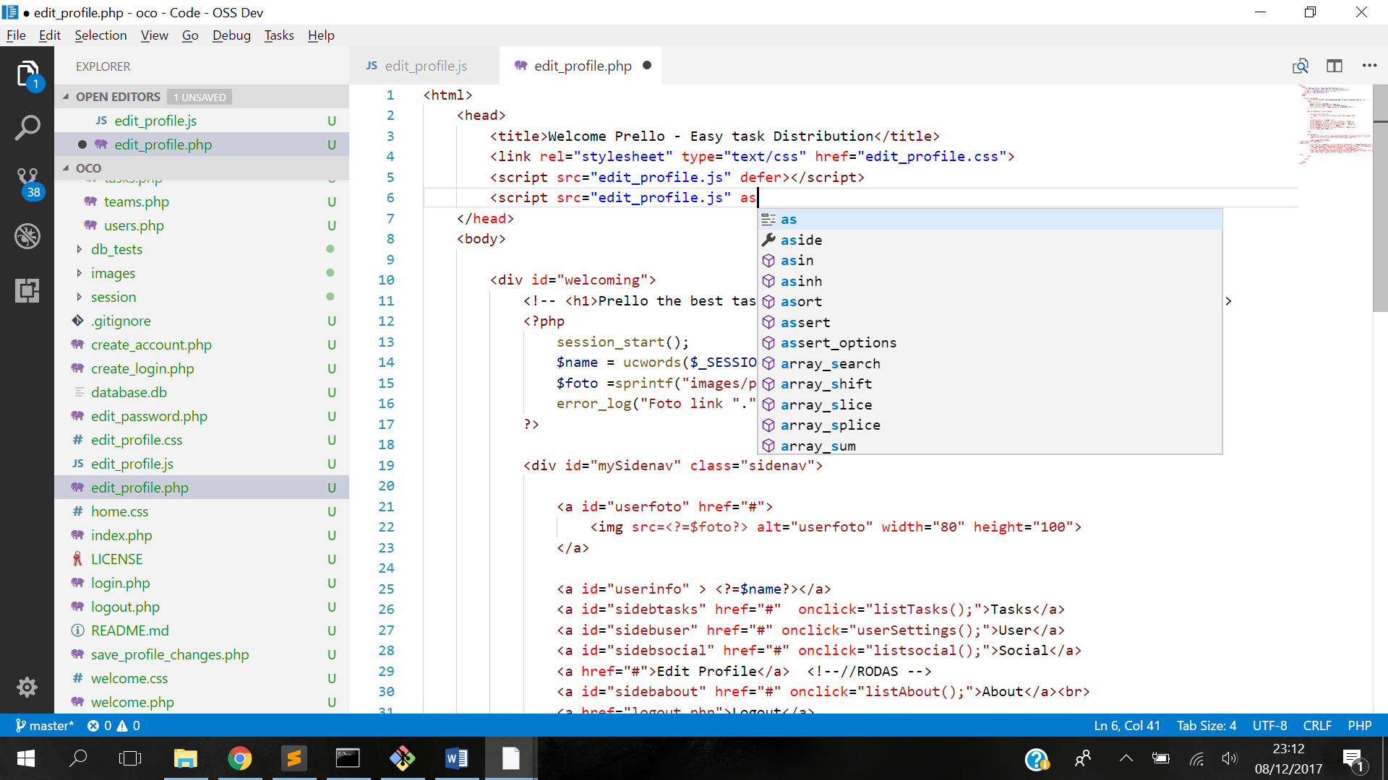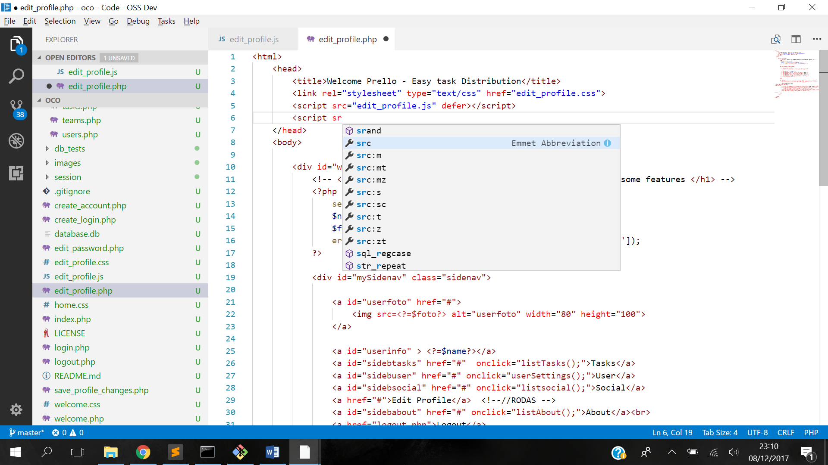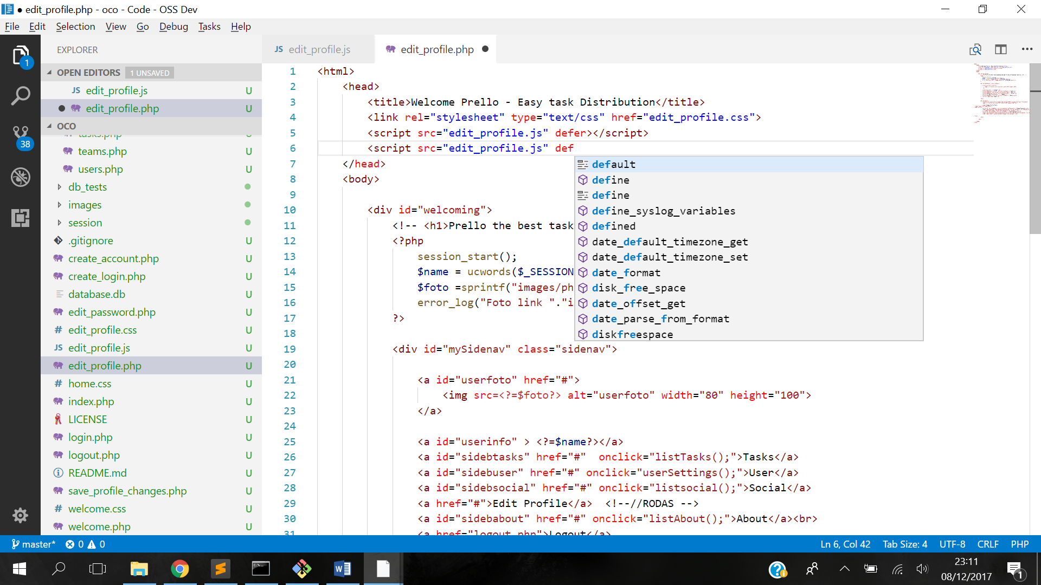

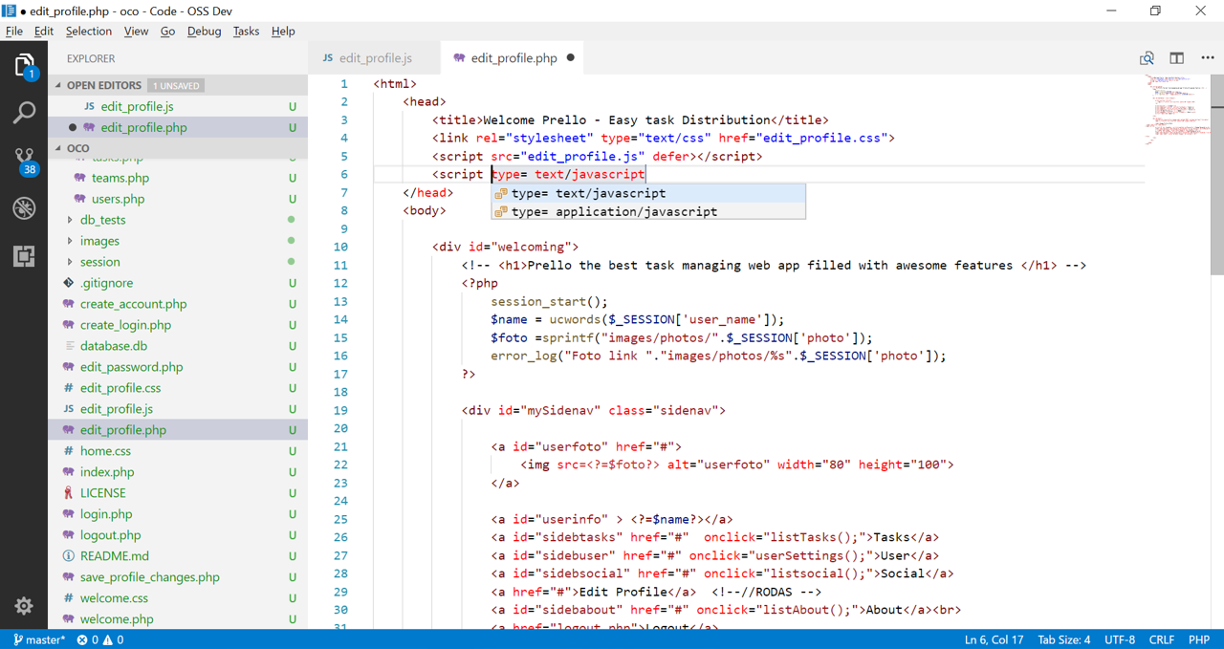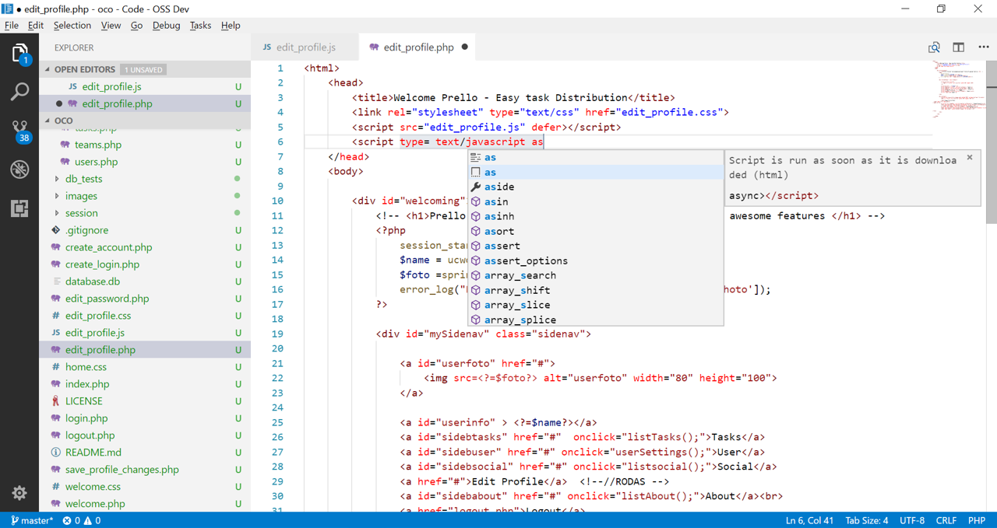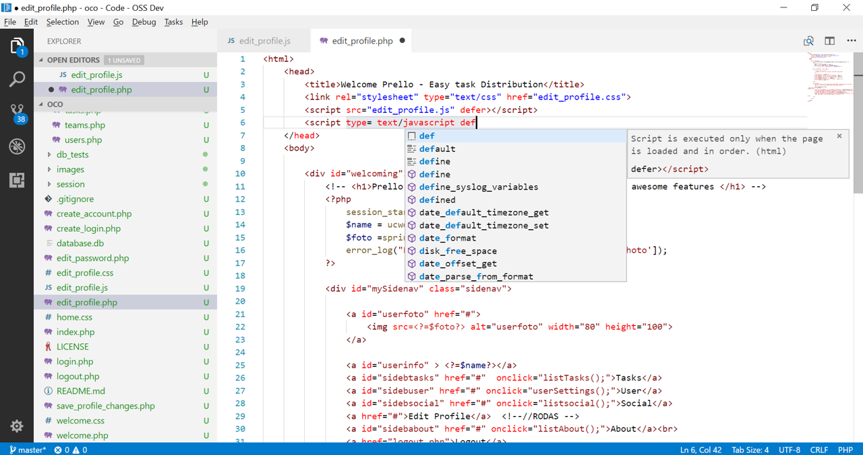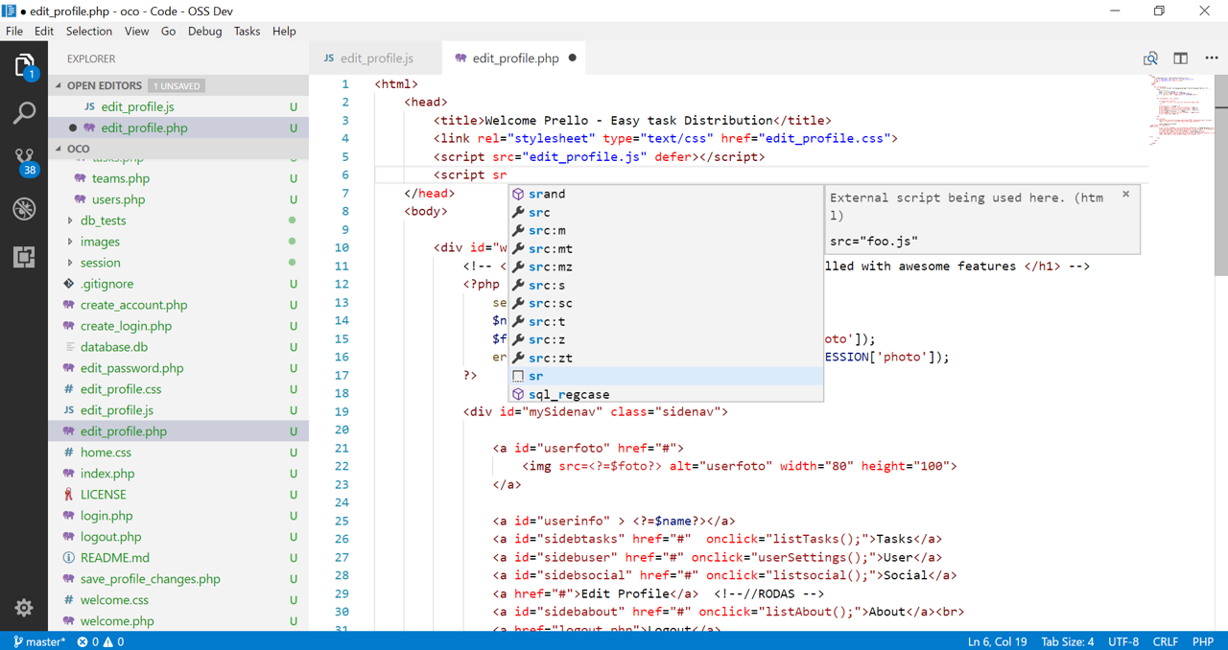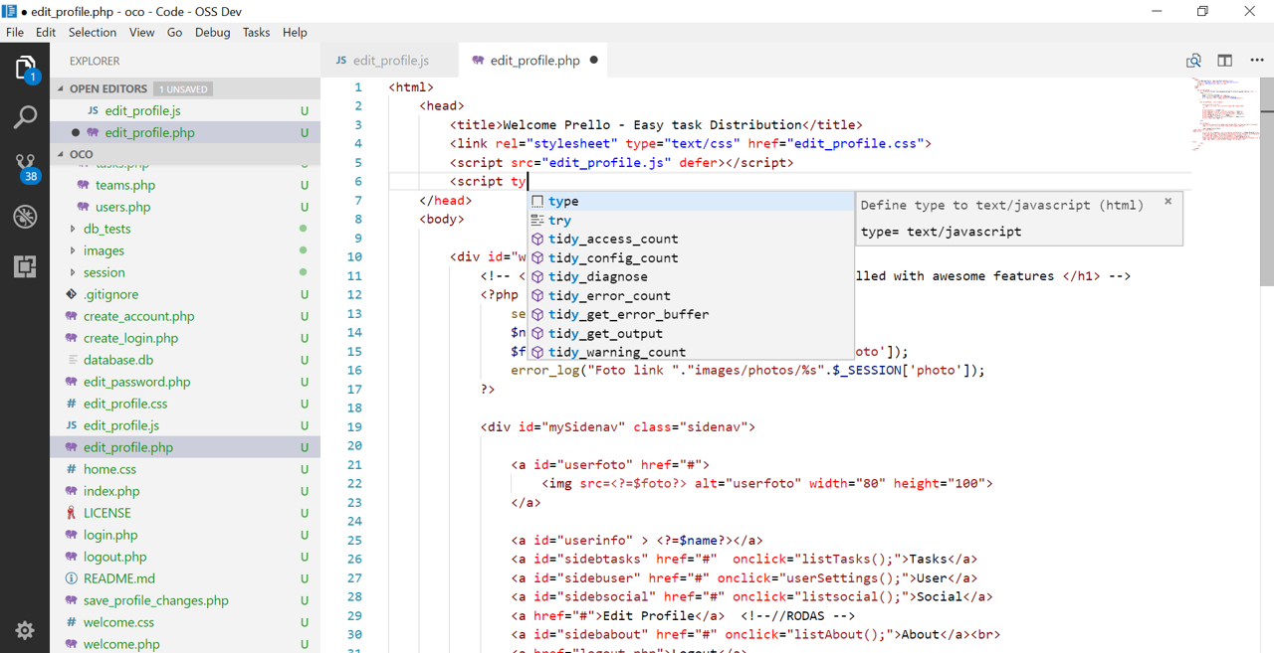What was intended was that VScode act like this:

Fig 7: Now, we can see that VScode suggests completion for html relatable code.

**Source code files:**

In order to solve the issue, we added new snippets in file [extensions/html/snippets/html.snippets.json](https://github.com/Microsoft/vscode/pull/39839/commits/34e006d12169f89c38aa0c35f5d67986c79fd41a#diff-67c08f9cfd40d9e92cff8c3522fe2187), from lines 24 to 55.

**Design of the fix:**

To solve this issue, we thought of how VScode could suggest code completion.

We thought a good way would be to add some snippets. Since this issue was specific to html code, we found the place where these snippets where mentioned and followed the path:

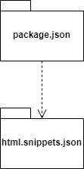

**Fix** **source** **code:**

extensions/html/snippets/html.snippets.json | 33 +++++++++++++++++++++++++++++

1 file changed, 33 insertions(+)

diff --git a/extensions/html/snippets/html.snippets.json b/extensions/html/snippets/html.snippets.json

index 7a858455a69..777b5fdce28 100644

--- a/extensions/html/snippets/html.snippets.json

+++ b/extensions/html/snippets/html.snippets.json

@@ -18,5 +18,38 @@

"</html>"

],

"description": "Simple HTML5 starting point"

+ },

+

+

+ "Script Type": {

+ "prefix": "type",

+ "body": [

+ "${1|type= text/javascript,type= application/javascript|}"

+ ],

+ "description": "Define type to text/javascript"

+ },

+

+ "Script async": {

+ "prefix": "as",

+ "body": [

+ "$async></script>"

+ ],

+ "description": "Script is run as soon as it is downloaded"

+ },

+

+ "Script defer": {

+ "prefix": "def",

+ "body": [

+ "defer></script>"

+ ],

+ "description": "Script is executed only when the page is loaded and in order."

+ },

+

+ "Script source": {

+ "prefix": "sr",

+ "body": [

+ "src=\"${1:foo}.js\" "

+ ],

+ "description": "External script being used here."

}

}

**Submit the Fix:**

The way it was supposed to submit fixes in our project is by doing a pull request, that can be found here:

<https://github.com/Microsoft/vscode/pull/39839>